ITCS 3153 – Intro to Artificial Intelligence

Midterm Study Guide

1. Know this image and the agent /environment interaction from percepts to actions.

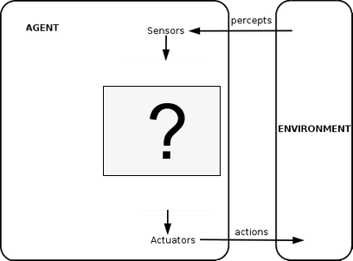

Agent Program

1. What is a Performance measure its impact on decision making.
2. Characteristics of Rational agents
3. Characteristics of types of environments
   1. **Fully vs. partially observable**
   2. **Single vs. multi agent**
   3. **Competitive vs. cooperative**
   4. **Deterministic vs**. **stochastic**
4. Be able to explain the Depth-limited search
5. Be able to explain the Iterative deepening depth-first search
6. Be able to use a depth-first and breadth-first search on a tree and determine the order that the nodes would be visited
7. A* Search
   1. Know the basic formula (f = g + h)
   2. Know what the openList and closedList are used for (what they hold)
   3. Know how the Manhattan method is used to calculate the heuristic.
   4. Know how the path is generated once the goal is reached.
8. 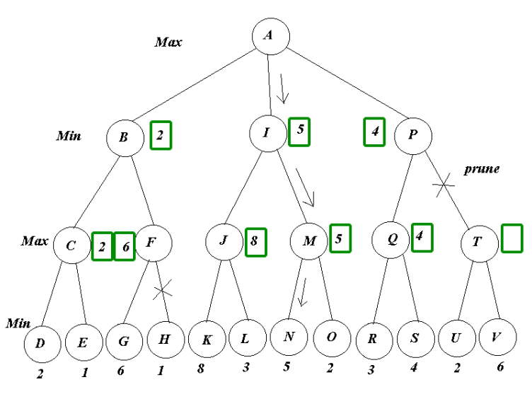Be able to explain how agents use the Minimax algorithm to make decision in an adversarial environment.
9. Be able to explain the concept behind pruning, why it’s

Useful, and be able to apply alpha-beta to a tree given

the utility functions of the terminal states.

Here’s an example of the one we did in class:

1. Be able to explain the characteristics of Knowledge-based agents, and how their knowledge base plays a role in how they make decisions.